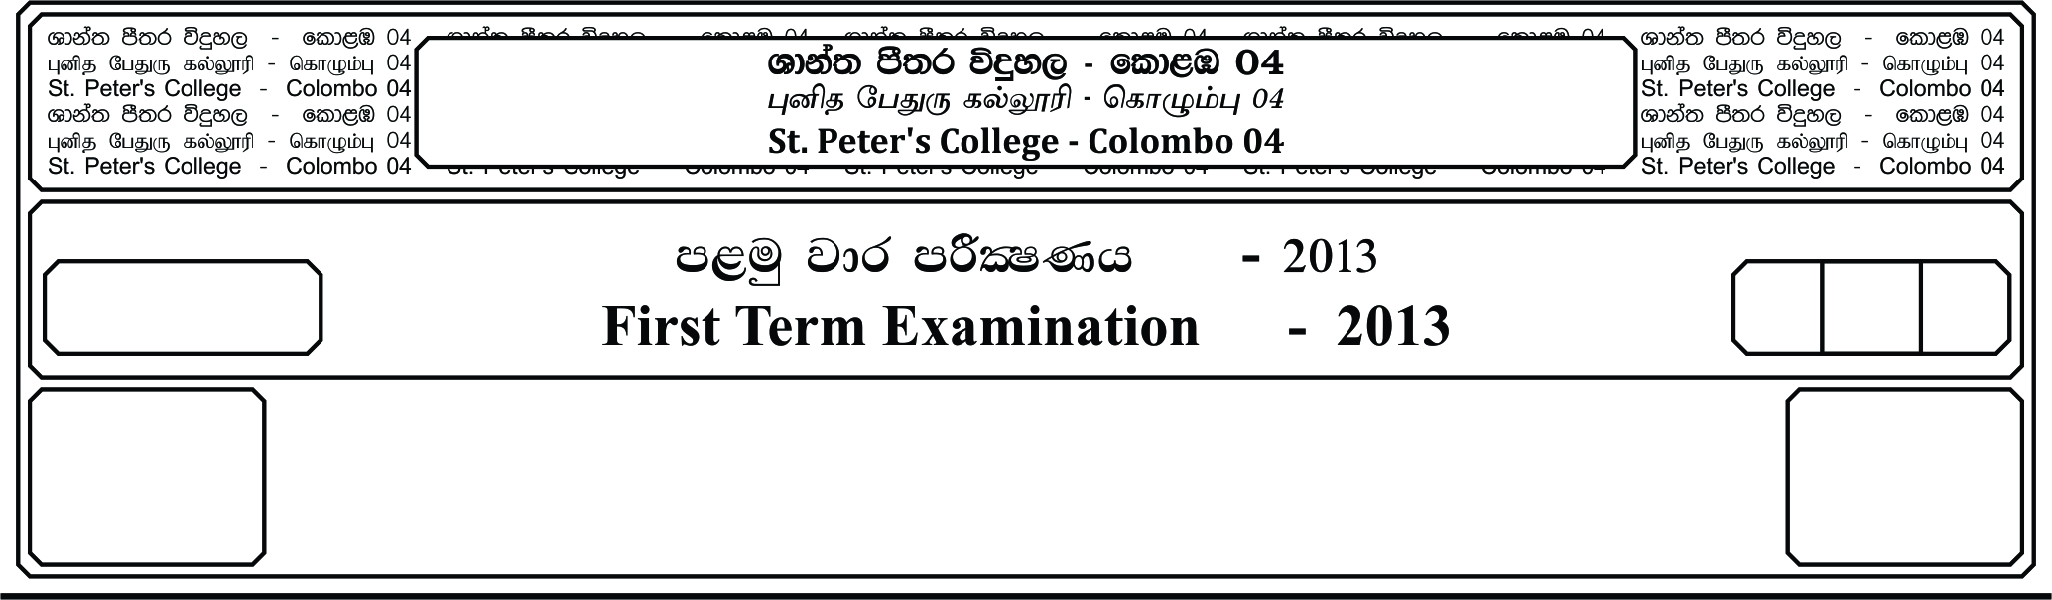

13 fY%aKsh

GRADE 13

E

meh 01

01 Hour

I

**m<uq jdr mÍCIKh - 2021**

**First Term Examination - 2021**

idudkH bx.%Sis - »

**GENERAL ENGLISH – I**

**Answer all the questions.**

**01. Fill the blanks with a suitable preposition given below.**

**[at , out , from , of for , to into , in , with , on]**

We all can get fright or be scared **1. ________________**animals. It could be a vicious looking dog that is wandering **2. ________________** the street or a cockroach that jumps **3. ________________** of a cup just when we want **4. ________________** make tea. These make our throat go dry and our hearts start beating quickly, or we jump back **5. ________________** our skin feeling like it is crawling. We are all a bit scared of spiders and bugs – especially when they jump **6. ________________** on us.

When the National Geographic Crew filming alligators **7. ________________** Billie Swamp safari in Florida a huge alligator pulled the under water camera from their grasp. It was later found mostly undamaged except **8. ________________** scratch marks from the alligator.

American bees are much more tame than African bees. So when African bees were introduced **9. ________________** the USA, people quickly named them killer bees. But although bees are dangerous the crew was fully protected but when the bees swarmed angrily, wearing all that thick protection didn’t stop the crew members **10. ________________** getting scared. **(10 Marks)**

**02. Fill in the blanks with the correct from of the verb given in brackets.**

Jenifer was my business partner. We were not really friends. My house **1. ________________** (be) just round the Corner from the Jenifer’s. I **2. ________________** (live) here for two years now. I **3. ________________** (buy) this house when I started **4. ________________** (earn) a lot of money.

I can’t really tell you very much about the night Jenifer died. I took my dog for a walk that evening. I **5. ________________** (go) up on the hills away from the village. Anyhow I **6. ________________** (lose) my dog in the dark. I **7. ________________** (seek) in vain for somewhere to go for help. Suddenly I heard someone **8. ________________** (cry). When I looked back I noticed it was Janet, The daughter of Jenifer. She **9. ________________** (seem) rather upset. As it was no use to speak to her, I **10. ________________** (run) towards their house as fast as I could. **(10 Marks)**

**03. Match the words for the sentences given below.**

**[Suggestion , Supplementary , adventure , archery , rafting]**

1. A dangerous but exciting activity. __________________________________________

2. Something you believe to be a good thing to do. _______________________________

3. A kind of sport practiced with a bow and arrow. _______________________________

4. Extra , additional _______________________________________________________

5. A type of sport practiced in rivers that flow fast. _______________________________

**(05 Marks)**

**04. Join the following pairs of sentences using the most appropriate conjunction from those given in brackets and rewrite the sentence.**

1. I was reading a novel. My brother was playing football with his friends **(if, while, although)**

_____________________________________________________________________

2. Nimal did not go to school. He had to take his mother to hospital

**(when, although, because)**

_____________________________________________________________________

3. You cannot leave this place. You finish your work. **(if, unless, as)**

_____________________________________________________________________

4. He rushed to the police station. He got the message. **(as soon as, as long as, so that)**

_____________________________________________________________________

5. You can take up this. You are willing to work hard. **(unless, provided, until)**

_____________________________________________________________________

**(05 Marks)**

**05. Read the paragraph and answer the questions given below.**

**Deep – Sea wildlife**

The largest wildlife habitat on earth can be found in the depth of the sea. No plants can grow because there is no sunlight. Yet many extraordinary creatures live here in the vast blackness. Some of the animals that live in the deep, feed on the bodies and remains that sink down from the surface. Other fish have enormous mouths and long teeth and can swallow anything that swims by. Animals that live in the deep can survive using little oxygen and can also go months without meal.

Hundreds of deep-sea fish can create their own light through chemical reactions including angelfish, stick heads and lantern fish. This is called bioluminescence. They use their light to guide them through the darkness or attract prey. Some creatures on the sea floor like sea anemones, sea cucumbers, worms, crabs and prawns sieve through mud searching for tiny pieces of food. Squids, shrimps and jellyfish can also be found on the deep-sea floor.

The lantern fish lives in the dark water hundreds of meters below the surface. It feeds on tiny floating plants and animals and watches for predators with its large eyes. It has spots along its body that glow. Scientists believe they uses these spots to see food or confuse other fish.

a. Why can’t plants grow at the bottom of the sea?

_____________________________________________________________________

_____________________________________________________________________

b. Write down three different creatures that live on the deep-sea floor.

_____________________________________________________________________

_____________________________________________________________________

c. Explain in your own words the word “bioluminescence”

_____________________________________________________________________

_____________________________________________________________________

d. Write down three facts that you have learned from this article.

_____________________________________________________________________

_____________________________________________________________________

_____________________________________________________________________

**Find synonyms from the passage for the following words.**

1. dwelling -

2. exceptional –

3. huge

**(05 Marks)**

**06. Form the correct formation of word given in brackets and fill the blanks.**

1. Most young ________________ have difficulty concentrating in class **(learn).**

2. It’s time to do some ________________ before the test **(revise)**.

3. It was the most ________________ day in my life **(stress).**

4. His career is really ________________. I think one day he will be someone important **(promise)**.

5. My grandparents visit was quite ________________. They never come to us on weekdays **(expect)**.

6. To my great ________________ I wasn’t told off **(astonish)**.

7. Have you ________________ what to wear for your prom yet? **(decision)**

8. My first job interview turned out to be ________________ **(disaster)**.

9. Smoking is a serious ________________ and some people don’t know. ________________ (addict)

10. That’s ________________ you’re late again and you haven’t even apologized **(believe)**. **(10 Marks)**

**07. Choose the correct answer from the list given below.**

1. English food is often considered too ________________ for foreigner’s tastes.

**(plane, plan, plain)**

2. My day at the health spa was ________________ bliss. **(sheer, merely, sheerly)**

3. Soldiers have been sent in to try to restore ________________ in the area.

**(harmony, organization, regulation)**

4. The police are ________________ an investigation into the robbery.

**(carrying out, working out, searching out)**

5. I really have no idea how the mistake ________________ in the first place.

**(come through, came off, came round)**

**(05 Marks)**

**08. Write a paragraph beginning with the given sentence. Use about 75 – 100 words. Do not exceed the word limit.**

Effective leadership requires specific qualities that one should develop ___________________

________________________________________________________________________________________________________________________________________________________________________________________________________________________________________________________________________________________________________________________________________________________________________________________________________________________________________________________________________________________________________________________________________________________________________________________________________________________________________________________________________________________________________________________________________________________________________________________________________________________________________________________________________________________________________________________________________________________________________________________________________________________________________________________________________________________________________________________________________________________________________________________________________________________________________________________________________________________________________________________________________________________________________________________________________________________________________________________________________________________________________________________________________________________________________________________________________________________________________________________________________________________________________________________________________________________________________________________________________________________________________________________________________________________________________________________________________________________________________________________________________________________________________________________________________________________________________________________________________________________

**(10 Marks)**